Layered Modular Monolith

Layers:
  - Presentation Layer (UI)
    - Responsibility: Handles HTTP Requests, handles and validates user inputs, and sends responses.
    - Dependencies: Application Layer (services)
  - Application Layer (Services)
    - Responsibilities: Orchestrates use cases and coordinates domain objects.
    - Dependencies: Domain Layer, Infrastructure (via interfaces)
  - Domain Layer (Business Logic)
    - Responsibility: Business rules and entities (Groups, Sessions, Meals)
    - Dependencies: none
  - Infrastructure Layer (Persistence)
    - Responsibilities: Database access, external APIs (payment gateways, email), and logging.
    - Dependencies: Domain interfaces, external libraries.

Core Modules:
  - Sessions
  - MealPeriod
  - Menu
  - MealPrep
  - Purchasing
  - Auth
Modules, Responsibilities, and Interfaces
- Sessions Module
- Responsibilities:
  - Manage retreat sessions for the camp.
  - Store high-level details, such as session name, date range, and status.
  - Attach groups (such as businesses, churches, or organizations) to each session.
  - Serve as the container for days and their MealPeriods.
- Key domain entities:
  - Session
  - Group
- Key interfaces:
  - SessionRepository
  - save(session)
  - findById(sessionId)
  - findActiveSessions()
  - GroupRepository
  - save(group)
  - findBySession(sessionId)
- Main application service:
  - SessionService
  - Create/update session
  - Add/edit groups for a session
  - Attach days and MealPeriods to a session (through coordination with the MealPeriod module)

- MealPeriod Module: A MealPeriod is a time slot within a day of a session, not a menu for guests.
- Responsibilities:
- Represent the schedule of eating times for each session.
- Define three MealPeriods per day, with MealPeriod.type equal to Breakfast, Lunch, or Dinner.
- Manage which Menu is assigned to each MealPeriod.
- Key domain entities:
  - MealPeriod
  - Fields: id, sessionId, dayIndex (or calendar date), type (Breakfast, Lunch, Dinner).
  - Holds reference to the assigned Menu(mealId).
- Key interfaces:
  - MealPeriodRepository
  - save(MealPeriod)
  - findBySession(sessionId)
  - findBySessionAndDay(sessionId, dayIndex)
- Main application service:
  - MealPeriodService
  - Initialize standard MealPeriods (Breakfast, Lunch, Dinner) for each day in a session.
  - Assign a Menu to a MealPeriod.
  - Change or clear the Menu assigned to a MealPeriod.

- Menus Module: Meals are what is actually cooked, not the time slots. A Menu can be reused in different sessions and MealPeriods.
- Responsibilities:
  - Manage Meals as reusable definitions.
  - Store what dishes, recipes, or simple food items are included in a Meal.
  - Store prep notes for kitchen staff.
- Key domain entities:
  - Meal
    - Name, description, notes.
  - Relationship: has many MenuItem.
  - MenuItem
    - Either a simple food item or a recipe reference.
  - For each item, store the quantity per person and the unit.
  - MenuItemIngredient(simple item, like fruit or bread)
  - Name, default unit of measure.
  - Recipe (if you support full recipes)
  - Name, steps, list of ingredients.
- Key interfaces:
  - MealRepository
  - save(meal)
  - findById(mealId)
  - findReusableMeals()
  - FoodItemRepository
  - save(foodItem)
  - findById(foodItemId)
  - RecipeRepository (if used)
  - save(recipe)
  - findById(recipeId)
- Main application service:
  - MealService
  - Create and edit Meals.
  - Add or remove MenuItems.
  - Attach FoodItems or Recipes to a Meal.
  - Support copying a Menu for reuse.

- MealPrep Module: Handles what the kitchen needs to do for a specific session and MealPeriod.
- Responsibilities:
  - Generate prep instructions and ingredient totals for a specific MealPeriod in a session.
  - Combine group headcounts with the assigned Menu definition.
  - Output a prep sheet that the kitchen can use as a reference.
- Key domain entities:
  - PrepSheet
  - For a specific Session, MealPeriod, and assigned Meal.
  - Includes headcount, dish list, total ingredient quantities, and high-level prep notes.
- Key domain services:
  - PortionCalculator
  - Input: Session, Groups, MealPeriod, Meal.
  - Output: ingredient totals per MenuItemIngredientor Recipe.
- Key interfaces:
  - PrepSheetRepository (optional)
  - save(prepSheet)
  - findBySessionAndBlock(sessionId, MealPeriodId)
- Main application service:
  - MealPrepService
  - generatePrepSheet(sessionId, MealPeriodId)
  - Uses SessionRepository, GroupRepository, MealPeriodRepository, MealRepository, and PortionCalculator.

- Purchasing Module: Aggregates all ingredient needs over a specified date range or for the entire session, allowing the camp to place a food order.
- Responsibilities:
  - Generate a purchasing list for all meals across a session or selected days.
  - Aggregate ingredient quantities from all MealPeriods and Meals.
  - Group by MenuItemIngredientand unit.
- Key domain entities:
  - PurchasingList
    - Session, date range, generated at timestamp.
    - Holds many PurchasingListItem.
    - PurchasingListItem
    - FoodItem, total quantity, unit of measure.
- Key domain services:
  - IngredientAggregationService
  - Aggregates ingredient totals across many MealPeriods and Meals.
  - Often reuses PortionCalculator logic from MealPrep.
- Key interfaces:
  - PurchasingListRepository (optional)
  - save(purchasingList)
  - findBySession(sessionId)
- Main application service:
  - PurchasingService
  - generateForSession(sessionId)
  - generateForDateRange(sessionId, fromDate, toDate)

- Auth Module
- Responsibilities:
  - Provide a single admin login identity.
  - Handle password hashing and verification.
  - Restrict access to the session and Menuplanning screens
- Key domain entities:
  - User
  - Username, hashed password, and role (currently, just Admin).
- Key interfaces:
  - UserRepository
  - findByUsername(username)
  - save(user)
  - PasswordHashingService
  - hash(plainPassword)
  - verify(plainPassword, hash)
- Main application service
  - AuthService
  - login(credentials)
  - changePassword(userId, newPassword)

Domain Class Relationship Diagram:
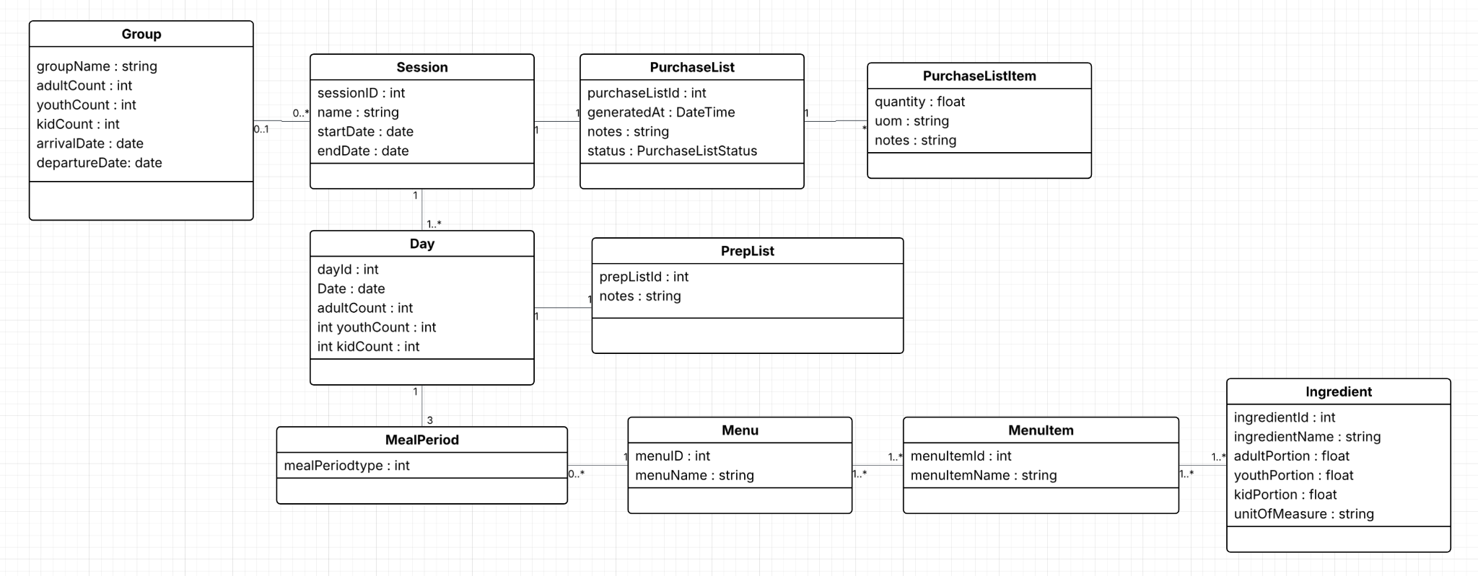
Layered Architecture Diagram:
